**TRACING THE GROWTH OF THE GLOBAL COMMUNITY: A POPULATION FORECASTING ANALYSIS**

**INTRODUCTION**

**Project Description:**

The world’s population is more than three times larger than it was in the mid-twentieth century. The global human population reached 8.0 billion in mid-November 2022 from an estimated 2.5 billion people in 1950, adding 1 billion people since 2010 and 2 billion since 1998. The world’s population is expected to increase by nearly 2 billion persons in the next 30 years, from the current 8 billion to 9.7 billion in 2050 and could peak at nearly 10.4 billion in the mid-2080s.

This dramatic growth has been driven largely by increasing numbers of people surviving to reproductive age, the gradual increase in human lifespan, increasing urbanization, and accelerating migration.

Major changes in fertility rate have accompanied this growth. These trends will have far-reaching implications for generations to come.

**Purpose of the project:**

We estimate the population growth of the world by using Visualizations considering the population records by the type of Countries, by Cities and population trends over the years and by Sex considering the factors which lead to population growth like increase in human lifespan, urbanization and migration.

The index is used to compare the population growth of different countries and trends over the years.

The final outcome of this project would be a report that presents the findings of analysis of human growth population.

**PROBLEM DEFINITION & DESIGN THINKING**

**EMPATHY:**

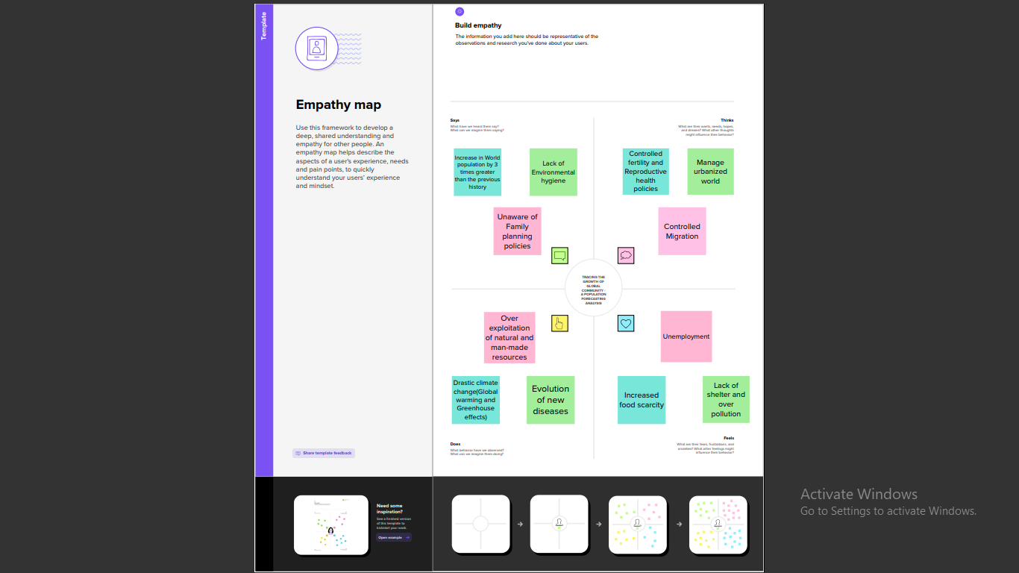

**IDEATION AND BRAINSTROMING MAP :**

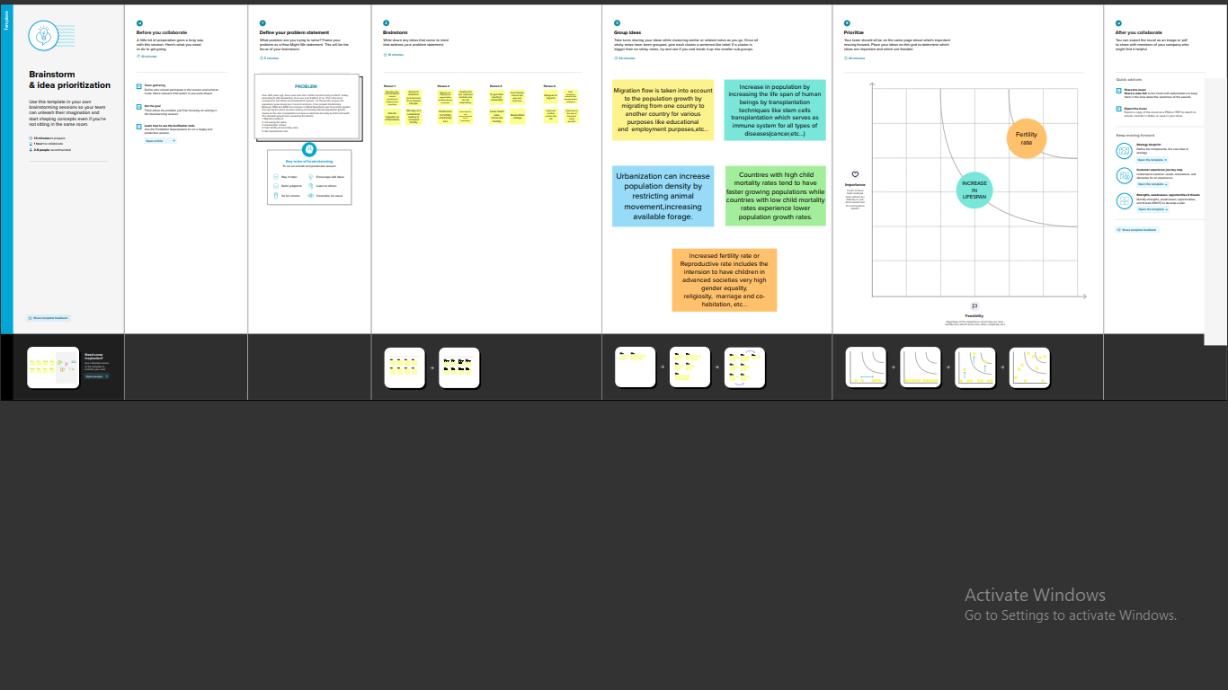

**RESULT:**

**OUTPUT**

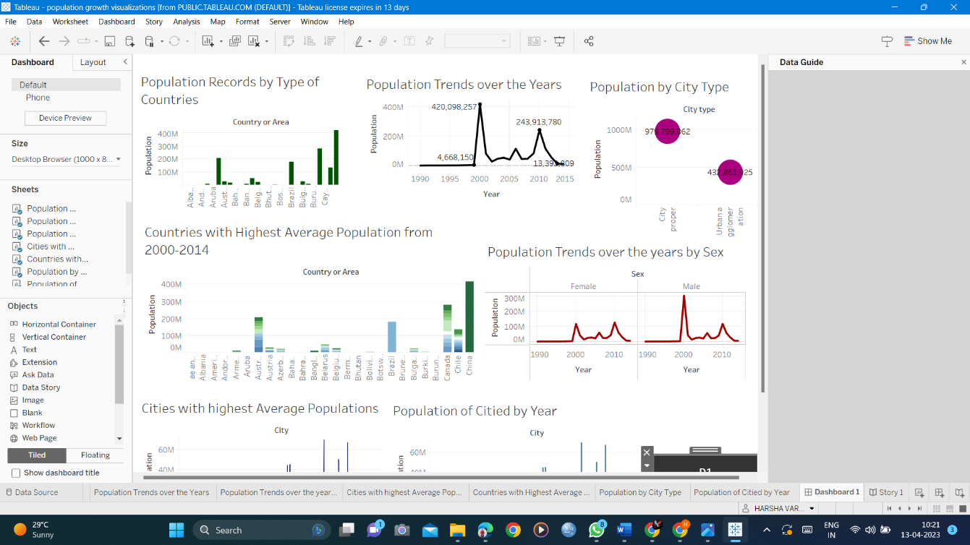

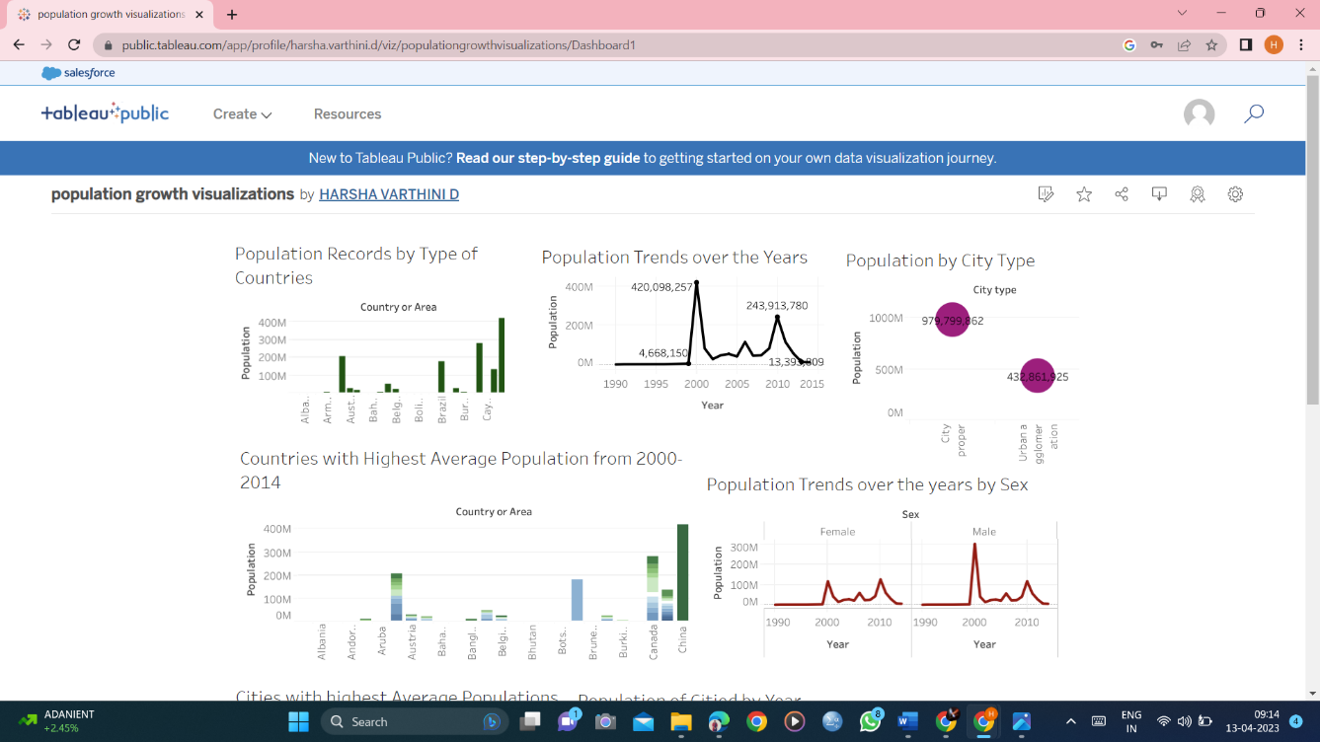

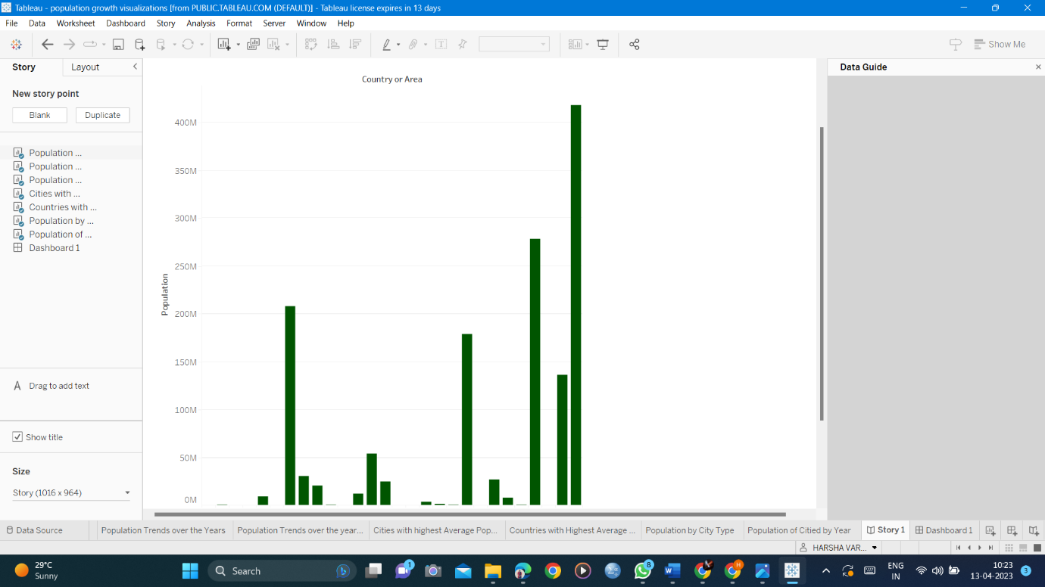

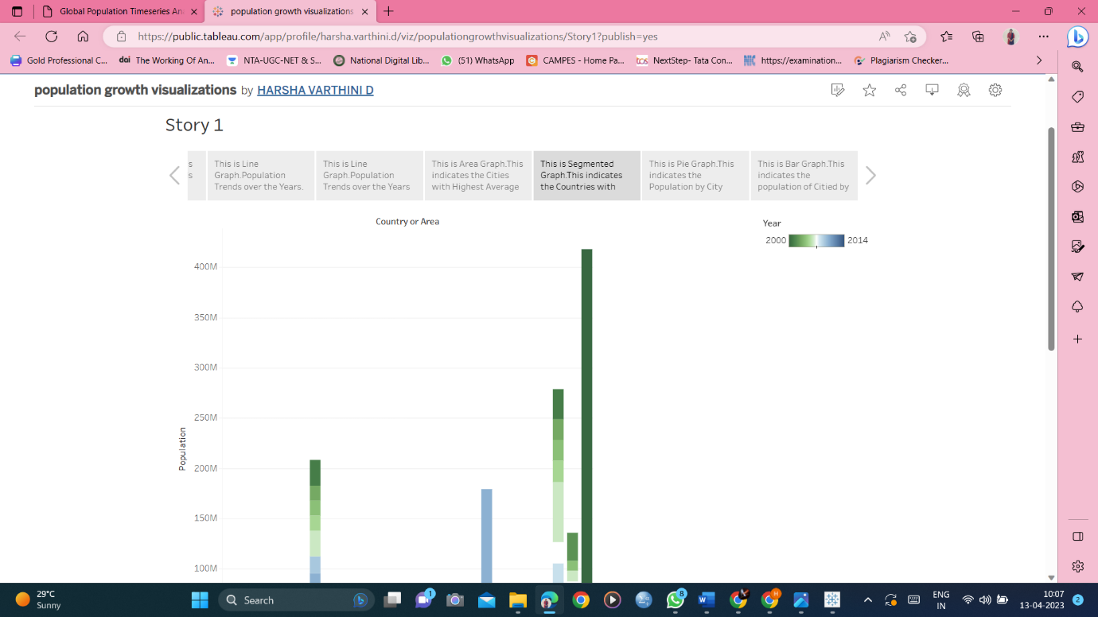

**TABLEAU PUBLIC:**

**DASHBOARD AND STORY**



**ADVANTAGES & DISADVANTAGES :**

**ADVANTAGES OF A DECREASING POPULATION**

**Long term benefits**

* Will bring better balance among the living beings/organisms.
* Extinction of Religions and Gods
* People will celebrate life. I think there will be no artificial, man-made death in the name of God(s), Religion, Nationality etc.,
* People will die only by natural causes. The remaining few (People) will support each other to save the life other every other person.

**Short term benefits**

* Less pollution, Lesser need for food, land and other resources.
* More pet animals are saved from the harassment of humankind and live in their natural habitat. They may live happily (may be unhappily at times) with their Father, Mother, Sisters, Brothers and could escape from the confinement.

**DISADVANTAGES OF A DECREASING POPULATION**

* **Long term impact** - extinction of languages, culture, food choices
* **Short term impact** - economy will shrink, more unemployment, population will have fewer young people supporting huge number of elders.
* The streets, seemingly empty streets, buildings etc., may look devilish.

**APPLICATIONS:**

There are some applications associated with population growth, including,

* Human evolution studies, the population growth is helped to study and observe the advancements in both anatomy and physiology.
* a growing population can be a result of many advantageous or beneficial traits or characteristics.
* To estimate global population size and annual growth rate.
* To estimate changes in population trends
* To predict the future population

**CONCLUSION:**

We worked on this project by demonstrating various visualizations on population records by the types of countries and cities, population trends over the years by sex and average highest population in order to decrease the population growth in the upcoming years, hence measuring the world population accurately and efficiently. Finally we will be able to decrease the world population growth by controlling some factors such as medicines used for lifespan, migration, reproductive age etc.,

**FUTURE SCOPE:**

The current world population of 7.6 billion is expected to reach 8.6 billion in 2030, 9.8 billion in 2050 and 11.2 billion in 2100, according to a new United Nations report being launched today. With roughly 83 million people being added to the world’s population every year, the upward trend in population size is expected to continue, even assuming that fertility levels will continue to decline.

The World Population Prospects: The 2017 Revision, published by the UN Department of Economic and Social Affairs, provides a comprehensive review of global demographic trends and prospects for the future. The information is essential to guide policies aimed at achieving the new Sustainable Development Goals.

Vasectomy and tubectomy are the surgical methods practiced for the birth control. Increase the age limit for marriage and completely detain child marriage. Remove social stigma associated with the sexual health and educate school adolescence about the same.